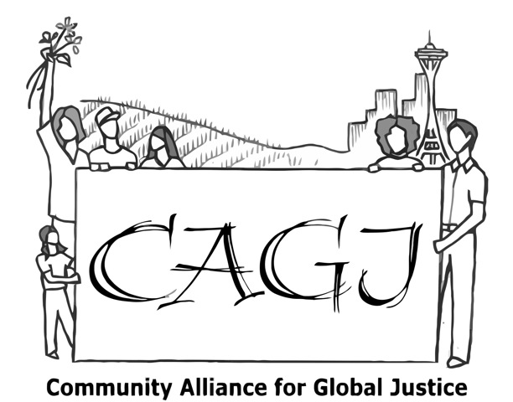
NO WAL-MART IN OUR COMMUNITIES!

Today is Food Day! Community Alliance for Global Justice joins the Making Change at Wal-Mart Campaign to celebrate Food Day by raising awareness about Wal-Mart’s attempts to open new, smaller “neighborhood – friendly” stores in the Puget Sound region. We know Wal-Mart is considering 23rd & Jackson as a potential new store site. We say “NO Wal-Mart in our Communities!” Why?

BAD FOR WORKERS
Wal-Mart provides low-quality jobs. Many workers are forced to accept part time hours with low pay and few benefits. Keeping labor costs low increases their profit margins, but is bad for workers and their families.
"On average, Wal-Mart store openings reduce retail employment by about 2.7 percent, implying that each Wal-Mart employee replaces about 1.4 employees in the rest of the retail sector" (Neumark, 28). Based on 2005 data, Washington State could expect to have an additional 7,204 retail jobs if retail stores other than Wal-Mart had opened where Wal-Mart currently exists (1% Walmart).

BAD FOR TAXPAYERS
Wal-Mart’s low wages cause a disproportionate number of employees to rely on state-funded medical coverage and emergency room visits.
Wal-Mart employees are consistently the number one users of state-funded medical programs (DSHS 2010). In 2006, taxpayers subsidized $12 million worth of care, not including the increased number of emergency room visits or coverage of children who qualified for Medicaid (Seattle Times, 2006).

BAD FOR COMMUNITY MEMBERS
As the largest retailer in the world, Wal-Mart leverages its enormous size to squeeze profits from workers and food distributors. By replacing decent jobs in the grocery industry with poor quality jobs, it forces small businesses to compete with its unfair labor practices. This diminishes the quality of our job market for all and reduces opportunities for small businesses.
BAD FOR FARMERS & EATERS
Because of their huge market power and drive for profit, Wal-Mart squeezes every supplier. Every link in the food chain, from farmers to eaters, suffers, as farmers get unfair prices, farmworkers get unfair pay, and eaters get lower quality food as a result- even if it’s labeled organic.
LEARN MORE:
Making Change at Wal-Mart is a national campaign to hold Wal-Mart accountable for its harmful impact on workers and communities. Over two dozen local organizations, including CAGJ, have joined the Making Change at Wal-Mart, Puget Sound coalition to support Wal-Mart workers locally, and to challenge Wal-Mart’s attempts to expand further in our communities. www.makingchangeatwalmart.org/; Facebook: fb.me/ChangeWalmartPugetSound

OUR Wal-Mart is a community of Wal-Mart workers nationwide demanding respect and fair working conditions. www.forrespect.org/

For a detailed analysis of the specific effects of a new Wal-Mart store, see “The Economic Impact of a Wal-Mart Store in the Skyway Neighborhood of South Seattle.” Christopher S. Fowler. April 5, 2012. Puget Sound Sage: http://www.pugetsoundsage.org/downloads/Walmart-Fowler-Report-2012-04-06_1.pdf.

For a detailed analysis of Walmart’s impact on the food system, see Food and Water Watch report, “Why Walmart Can't Fix the Food System": http://www.foodandwaterwatch.org/reports/why-walmart-cant-fix-the-food-system/

About Food Day –Oct 24: www.foodday.org
About World Food Day – Oct 16: www.usfoodsovereigntyalliance.org

Other Sources:
“Employment Status of Medical Assistance Clients and Persons with Dependents with DSHS Medical Coverage.” Washington State Department of Social and Health Services. 2010.
"Hidden Cost of Walmart Jobs: Use of Safety Net Programs by Wal-Mart Workers in California." Dube, A. And K. Jacobs (2004). U.C. Berkeley Labor Center Briefing Paper Series.
“State Subsidy to Wal-Mart Employees put at $12 Million.” Ralph Thomas. February 8 2006. http://seattletimes.com/html/localnews/2002791346_walmart07m.html.
"The Effects of Wal-Mart on Local Labor Markets." David Neumark et al . National Bureau of Economic Research. November 2005. http://www.nber.org/papers/w11782.
The Wal-Mart 1 Percent. http://walmart1percent.org/washington/.

Community Alliance for Global Justice
As part of the Making Change at Wal-Mart Coalition, CAGJ has organized this action in celebration of Food Day.
CAGJ works to strengthen local economies, everywhere.
206-405-4600 contact_us@seattleglobaljustice.org www.seattleglobaljustice.org

